Category-wise Product Analysis Report
The Category-wise Product Analysis is used to analyze products based on their categories. The following SQL queries display products, count products, find the highest-priced product, identify categories with more than 5 products, and calculate the average price of products in each category.

Display All Products Under Each Category

SELECT p.product_id,
p.product_name,
p.price,
c.category_name
FROM product p
JOIN category c
ON p.category_id = c.category_id;

Explanation:
This query displays each product along with its price and corresponding category.
Output

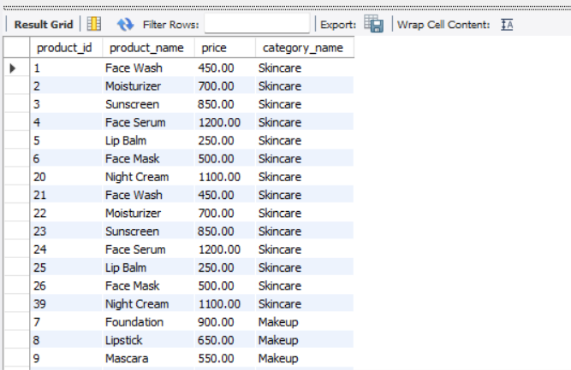
Count Number of Products in Each Category

SELECT c.category_name,
COUNT(p.product_id) AS product_count
FROM category c
LEFT JOIN product p
ON c.category_id = p.category_id
GROUP BY c.category_id, c.category_name;

Explanation:
The COUNT() function counts the number of products in each category.

Output
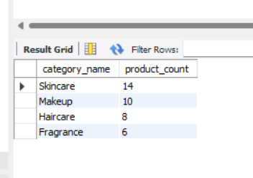

Find the Highest-Priced Product in Each Category

SELECT c.category_name,
p.product_name,
p.price
FROM category c
JOIN product p
ON c.category_id = p.category_id
WHERE p.price = (
SELECT MAX(p2.price)
FROM product p2
WHERE p2.category_id = p.category_id
);

Explanation:
The MAX() function finds the highest price within each category.

Output:
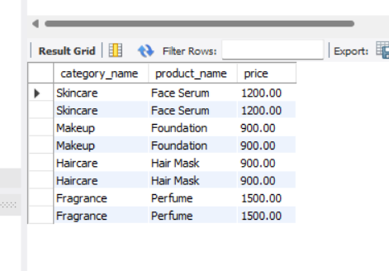

Display Categories Having More Than 5 Products
SELECT c.category_name,
COUNT(p.product_id) AS product_count
FROM category c
JOIN product p
ON c.category_id = p.category_id
GROUP BY c.category_id, c.category_name
HAVING COUNT(p.product_id) > 5;

Explanation:
The HAVING clause filters the categories and displays only those having more than 5 products.

Output:
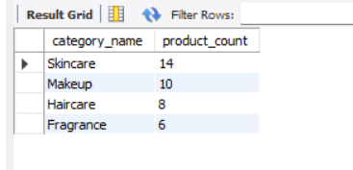

Find Average Product Price Category-wise

SELECT c.category_name,
AVG(p.price) AS average_price
FROM category c
JOIN product p
ON c.category_id = p.category_id
GROUP BY c.category_id, c.category_name;

Explanation:
The AVG() function calculates the average price of products in each category.

Output:
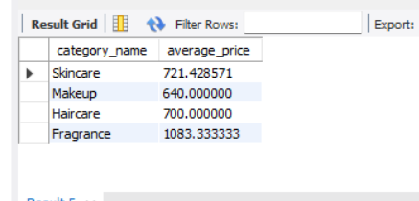

Analysis Summary
Based on the category-wise analysis:
- Skincare has the highest number of products with 6 products.
- Makeup has 5 products.
- Haircare has 4 products.
- Fragrance has 3 products.
- Perfume is the highest-priced product overall at ₹1500.
- Fragrance has the highest average product price at ₹950.
- Only Skincare has more than 5 products.

